**1 Project Overview**

SmartAlto is a SaaS company that helps real estate agents set 15-minute phone appointments with homebuyers through automated follow-ups. This is an AI built UP technology that sends text messages to those homebuyers within 2 minutes, asks them a few simple questions, and then sets 15-minute phone appointments on the real estate agent’s calendar. That way, the homebuyer always gets their questions answered and can then schedule time with the real estate agent to go see the home. It offers features like property intelligence, lead generation, sales automation, AI data enrichment, and appointment setting. The system backfills missing contact data, automates outreach with personalized messages, and identifies potential sellers in user databases. It also includes conversational AI, A/B testing, and a command canter for streamlined workflows.

This case study explores how SmartAlto scaled from $0 to $323,010.43 in 14 months using strategic ads, automated scheduling, community building, social proof, and optimized pricing.

**2. Business Goal:**

Achieve $323,010.43 in revenue within 14 months through AI-driven lead generation and sales automation for real estate agents.

**3. Business Objectives**

* **Increase website conversions** – The target is to convert at least 3% of website visitors into demo bookings.
* **Automate appointment scheduling** – Minimize manual effort for real estate agents.
* **Increase customer lifetime value (LTV)** – Secure higher revenue through flexible and value-based pricing.
* **Establish market authority** – Build trust and credibility through social proof and a professional community.

**4. Scope**

**4.1 In-Scope**

* Running targeted ad campaigns (Facebook, Google).
* Developing a high-converting landing page.
* Automating customer engagement and appointment scheduling.
* Creating and managing a professional Facebook group.
* Offering flexible pricing plans and securing annual deals.

**4.2 Out of Scope**

* Custom software development.
* Direct customer service outside automated systems.

**5. Key Components**

**5.1 Sales Funnel**

* **Targeted Ads:**
  + Ran highly targeted Facebook and Google ads.
  + Focused on real estate agents and homebuyers searching for properties.
  + Ad variations included:
    - **Direct Response Ads:** Designed to trigger immediate action.
    - **Social Proof Ads:** Featured customer testimonials and success stories.
    - **Retargeting Ads:** Focused on visitors who didn’t convert initially.
    - **Performance-Based Ads:** Highlighted appointment setting statistics and real-time results.
    - **Educational Ads:** Explained the value of SmartAlto’s solution.
  + Adjusted targeting and copy based on ad performance and conversion data.

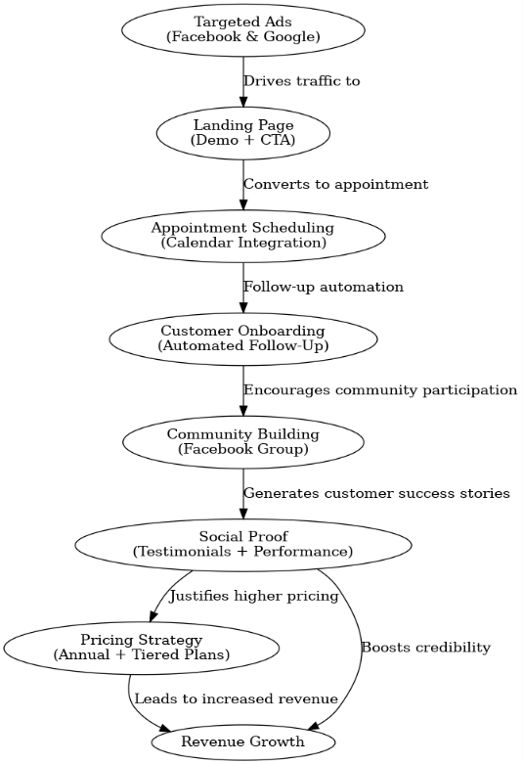

* **Landing Page:**
  + Short, 5-minute demo video showing real-world results (48 appointments in 20 days).
  + Clear CTA (Clear Call-to-Actions) button (“Schedule a Demo”) placed prominently.
  + Positioned testimonial directly below CTA (Clear Call-to-Actions) for social proof.
  + Direct calendar integration for instant scheduling.
  + Mobile-friendly and fast-loading.

**5.2 Community Strategy**

**1. Facebook Group:** Created "Real Estate Marketing Mastermind Group" – strategically named to focus on customer value, not for brand.

**2. Entry Questions:** Collected valuable market research through three entry questions to know the customers better way :

* What’s your biggest challenge with lead follow-up?
* What are your current strategies?
* What tools do you currently use?

**3.Community Engagement:**

* + Hosted expert and customer training sessions and interviews
  + Encouraged members to share success stories.
  + Built trust and authority through direct interaction.

**5.3 Social Proof**

* **Performance Charts:** Displayed in Google Sheets to highlight the number of appointments set and success rates.
* **Customer Testimonials:** Video interviews showcasing customer success.
  + Highlighted before-and-after results showing improvements.
  + Demonstrated increased conversion rates after using SmartAlto.
* **Results-Based Videos:** Short videos showing:
  + How 48 appointments were set in 20 days.
  + Simple charts in Google Sheets to illustrate success rates.
  + Real estate agents describing their improved sales performance.

**5.4 Pricing Strategy**

* **Initial Pricing:**
  + Started at **$200/month**.
  + Lowered to **$27/month** (mistake) – undervalued the product and reduced perceived value.
* **Pricing Correction:**
  + Increased base plan to **$300/month** – positioned as a premium solution.
  + Introduced premium plans up to **$70,000/year**.
  + Focused on securing annual deals for better cash flow and higher LTV.
* **Custom Plans:**
  + Allowed flexibility for larger clients.
  + Delivered the same product at higher price points based on perceived value..
* **Annual Deals:**
  + Customers receive a discount for upfront annual payments.
  + Provides improved cash flow and reduces churn.
  + Higher upfront commitment increases customer retention.
* **Revenue Boost:**
  + Increased perceived value through higher pricing.
  + Focused on lifetime value (LTV) rather than short-term gains.
  + Higher-tier clients contribute to long-term revenue stability.

**6. Functional Requirements**

|  |  |
| --- | --- |
| **Requirement** | **Description** |
| Ads | Targeted Facebook and Google ads driving traffic to landing pages. |
| Demo Video | Short demo highlighting product value and real-world success. |
| Scheduling | Automated appointment setting integrated with real estate agent’s calendar. |
| Community | Professional Facebook group for customer engagement and feedback. |
| Pricing Strategy | Tiered pricing model with annual and custom plan options. |

**7. Non-Functional Requirements**

* **Performance:** Fast-loading website and quick response time.
* **Scalability:** Ability to handle increased traffic without performance degradation.
* **Security:** Secure handling of user data and appointment information.

**8. Risks and Mitigations**

|  |  |
| --- | --- |
| Risk | Mitigation Strategy |
| Low conversion from ads | Optimize targeting and test multiple ad variations. |
| High churn rate | Improve onboarding experience and customer support. |
| Competitor action | Focus on product differentiation and customer success stories. |
| Pricing pushback | Provide value justification through testimonials and performance data. |

**9. Success Metrics**

* Achieve a 3%+ website visitor-to-demo conversion rate.
* Secure at least 20% of customers on annual contracts.
* Grow the professional Facebook group by 10% month-over-month.
* Increase customer LTV through higher-tier pricing and annual plans.
* Automate 80% of outreach tasks

**10. Approval**

|  |  |  |
| --- | --- | --- |
| Name | Role | Date |
| Parishmita Rajbongshi | Business Analyst | [Date] |

**End of Document**